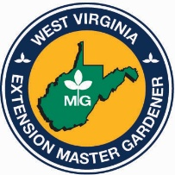

EXTENSION MASTER GARDENER ACTIVITY LOG

Name______________________ County_____________________ Year____________________

New Master Gardener Master Gardener Recertification

Date | Activity | Volunteer  Hours* | Education  Hours | Contacts |  |  | Expenses
 |  |  |  | M | F | Youth | Misc. Exp. | Mileage
 | Total Hours:

*Include travel time in hours. Note: Mileage & expense information is not required by WVU Extension; it is for your use as an income tax expense record.

To maintain your certification, you must participate in 10 hours of education and 20 hours of volunteer service each year. New members need 40 hours of service the first year.

Please return this form(s) to your Extension agent. ________________________________
Deadline – OCTOBER 1. Master Gardener Signature

